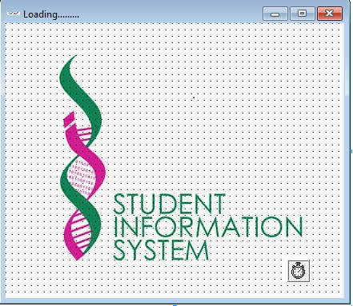**Student Registration System**

**Starting with Splash Form**

**Private Sub Form_Load()**

**End Sub**

**Private Sub Timer1_Timer()**

**Splash.Hide**

**frmLogin.Show**

**Timer1.Enabled = False**

**End Sub**

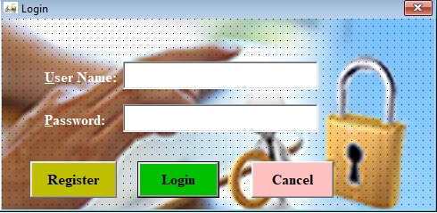**Login Form**

**Option Explicit**

**Public LoginSucceeded As Boolean**

**Private Sub cmdCancel_Click()**

**'set the global var to false**

**'to denote a failed login**

**LoginSucceeded = False**

**Me.Hide**

**End Sub**

**Private Sub cmdOK_Click()**

**'check for correct password**

**If txtPassword = "admin" Then**

**'place code to here to pass the**

**'success to the calling sub**

**'setting a global var is the easiest**

**LoginSucceeded = True**

**Me.Hide**

**Else**

**MsgBox "Invalid Password, try again!", , "Login"**

**txtPassword.SetFocus**

**SendKeys "{Home}+{End}"**

**End If**

**If txtUserName = "admin" Then**

**LoginSucceeded = True**

**Me.Hide**

**Form1.Show**

**End If**

**End Sub**

**Private Sub Register_Click()**

**Register.Show**

**Login.Hide**

**End Sub**

**Private Sub Form_Load()**

**End Sub**

**Register Form**

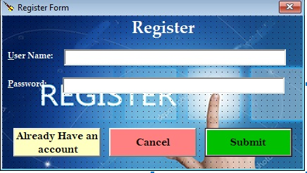

**Private Sub Already_Click()**

**Login.Show**

**End Sub**

**Private Sub Cancel_Click()**

**End**

**End Sub**

**Private Sub Form_Load()**

**Adodc1.Recordset.Update**

**Text1.Text = ""**

**Text2.Text = ""**

**End Sub**

**Private Sub Register_Click()**

**Adodc1.Recordset.Addnew**

**End Sub**

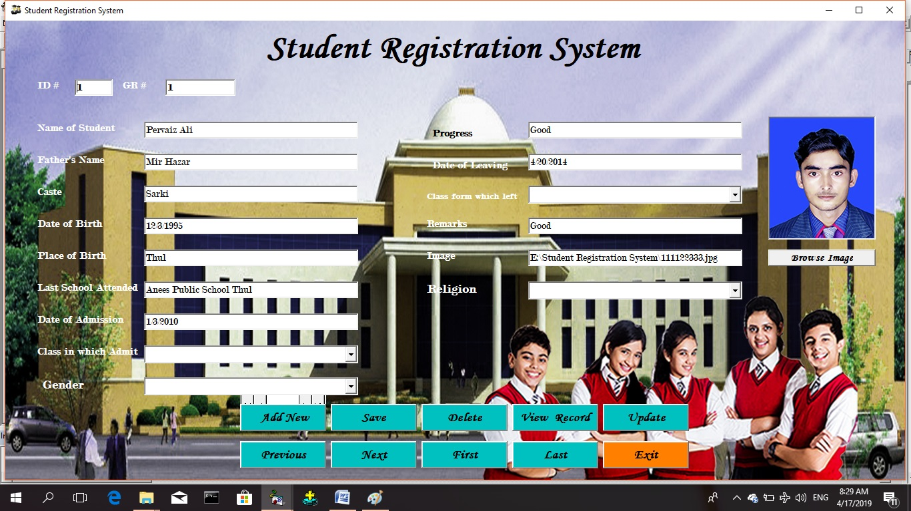**Student Registration Form**

**Private Sub Last_Click()**

**Adodc1.Recordset.MoveLast**

**End Sub**

**Private Sub Exit_Click()**

**Unload Form1**

**End Sub**

**Private Sub AddNew_Click()**

**Adodc1.Recordset.Addnew**

**clear**

**End Sub**

**Sub clear()**

**Text6.Text = "12/01/1947"**

**Combo1.Text = "Select Class"**

**Combo2.Text = "Select Class"**

**Combo3.Text = "Select Religion"**

**Combo4.Text = "Select Gender"**

**End Sub**

**Private Sub Update_Click()**

**Adodc1.Recordset.Update**

**MsgBox "Record Saved Successfully"**

**End Sub**

**Private Sub Delete_Click()**

**confirmation = MsgBox("Do you want to delete this record", vbYesNo + vbCritical, "Delete Record Confirmation")**

**If confirmation = vbYes Then**

**Adodc1.Recordset.Delete**

**MsgBox "Record has been Deleted Successfully", vbInformation, "Message"**

**Else**

**MsgBox "Record Not Deleted...!!", vbInformation, "Message"**

**End If**

**End Sub**

**Private Sub ViewRecord_Click()**

**Form2.Show**

**End Sub**

**Private Sub Text15_Change()**

**Picture1.Picture = LoadPicture(Text15.Text)**

**End Sub**

**Private Sub SaveBtn_Click()**

**Adodc1.Recordset.Update**

**MsgBox "Record Saved Successfully"**

**End Sub**

**Private Sub Previous_Click()**

**Adodc1.Recordset.MovePrevious**

**End Sub**

**Private Sub Next_Click()**

**Adodc1.Recordset.MoveNext**

**End Sub**

**Private Sub First_Click()**

**Adodc1.Recordset.MoveFirst**

**End Sub**

**Private Sub Form_Load()**

**Dim str As String**

**Combo1.AddItem "One"**

**Combo1.AddItem "Two"**

**Combo1.AddItem "Three"**

**Combo1.AddItem "Four"**

**Combo1.AddItem "Five"**

**Combo1.AddItem "Sixth"**

**Combo1.AddItem "Seventh"**

**Combo1.AddItem "Eighth"**

**Combo1.AddItem "Nineth"**

**Combo1.AddItem "Matric"**

**Combo4.AddItem "Male"**

**Combo4.AddItem "Female"**

**Combo2.AddItem "One"**

**Combo2.AddItem "Two"**

**Combo2.AddItem "Three"**

**Combo2.AddItem "Four"**

**Combo2.AddItem "Five"**

**Combo2.AddItem "Sixth"**

**Combo2.AddItem "Seventh"**

**Combo2.AddItem "Eighth"**

**Combo2.AddItem "Nineth"**

**Combo2.AddItem "Matric"**

**Combo3.AddItem " Islam"**

**Combo3.AddItem " Hindu"**

**Combo3.AddItem " Chiristian"**

**Combo3.AddItem " Jews"**

**End Sub**

**Private Sub UploadImage_Click()**

**CommonDialog1.ShowOpen**

**CommonDialog1.Filter = "Jpeg|*jpg"**

**Text15.Text = CommonDialog1.FileName**

**End Sub**

**Records Form**

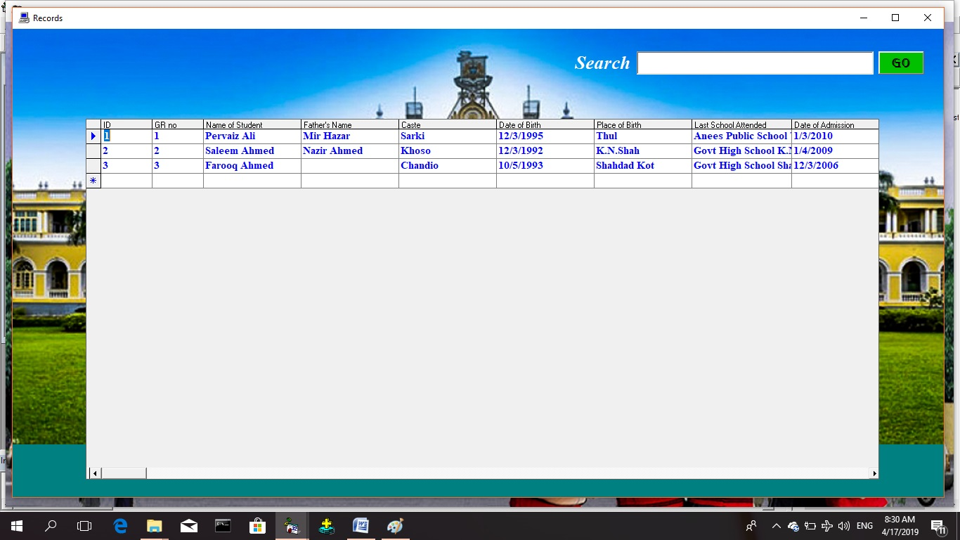

**Private Sub Form_Load()**

**End Sub**

**Private Sub GO_Click()**

**Adodc1.RecordSource = "Select * from Table1 where Name of Student = '" + Text1.Text + "' or Caste = '" + Text1.Text + "'"**

**If Adodc1.Recordset.EOF Then**

**MsgBox "Record Not Found", vbCritical, "Message"**

**Else**

**Adodc1.Caption = Adodc1.RecordSource**

**End If**

**End Sub**